
HEALTH, SAFETY & ENVIRONMENT MANAGEMENT SYSTEM
DAN Construction Safety Manual (DCSM)
Personal Protective Equipment (PPE)

Document Control
Document No. | 01-000001-000000-DAN-HSE-PRC-000017 | Revision | R01
Issue Date | June 2026 | Classification | Controlled — Internal
Document Owner | HSE Department | Page Format | US Letter

Table of Contents

1. Purpose
2. Scope
3. References
4. Deliverables
5. General Requirements
5.1 Activity Hazard Analysis
5.2 Selection, Provision and Maintenance
6. Types of PPE
6.1 Face and Eye Protection
6.2 Head Protection
6.3 Foot Protection
6.4 Respiratory Protection Equipment (RPE)
6.5 Arm and Hand Protection
6.6 Protective Clothing
6.7 Drowning Protection
7. Records
8. Related Documents
Figures and Illustrations
Revision History

1. Purpose
This document provides the requirements for the selection and use of Personal Protective Equipment (PPE) to give personnel eye, face, head, arm, hand, body and foot protection.
Note: Fall protection is not covered here — see the Fall Protection and Prevention / Working at Height chapter.

2. Scope
This document applies to all CONTRACTOR personnel on DAN project sites. PPE is used in conjunction with engineering, work-practice and administrative controls; specialised PPE not addressed here is determined through Activity Hazard Analyses (AHAs).

3. References
- ANSI Z87.1 / BS-EN 166 (eye and face); ANSI Z89.1 / BS-EN 397 (head); ANSI Z41 / BS-EN (foot)
- ANSI Z88.2; BS 4275; EN 137 / EN 139 (respiratory)
- DCSM — Activity Hazard Analysis (AHA)
- DCSM — Hazard Communication

4. Deliverables
- PPE Plan
- Provision of required PPE for all personnel

5. General Requirements
Unless otherwise stipulated, the following minimum mandatory PPE shall be worn at all times on DAN sites:
- ANSI/EN-approved safety glasses with side shields
- ANSI/EN-approved hard hats (SH&E induction sticker required; company logo recommended)
- ANSI/EN above-the-ankle safety boots
- High-visibility vest (company logo recommended)
A risk assessment of all planned activities shall determine project PPE requirements. Required PPE shall be furnished at no cost to personnel, and works shall not progress without the minimum requirements implemented. Exceptions to the minimum PPE must be approved by the DAN SH&E Representative.

5.1 Activity Hazard Analysis
AHAs identify tasks requiring PPE beyond the minimum; where indicated, the SH&E Representative selects the specific PPE. AHAs are conducted or updated when a new process or equipment is introduced, after an accident, when a job changes, or on request. Additional PPE is used only where hazards cannot be eliminated or controlled by engineering or administrative controls.

5.2 Selection, Provision and Maintenance
- The SH&E Representative (with the Superintendent and Project Manager) selects appropriate PPE based on the task, conditions, duration of use and identified hazards; PPE shall not interfere with work or create new hazards, and items worn together shall be compatible.
- Supervisors ensure the appropriate PPE is provided before work starts; where personnel provide their own PPE, the CONTRACTOR is responsible for ensuring its adequacy.
- All PPE shall be used and maintained clean and reliable; reusable items are disinfected before re-issue, and PPE that cannot be decontaminated is disposed of safely.
- Personnel shall inspect PPE before and after each use; defective PPE shall be removed from service.

6. Types of PPE

6.1 Face and Eye Protection
- Approved safety glasses with side shields shall be worn at all times on any project, except inside offices, inside enclosed vehicles, or when wearing goggles or a full-face respirator.
- Clear glasses are used for indoor/night activities; dark UV-protection glasses for outdoor sunlight.
- Personnel requiring prescription lenses shall wear prescription-incorporating eye protection or over-glasses; contact-lens wearers shall use appropriate eye/face protection in hazardous (e.g. dusty/chemical) environments.
- Goggles and/or a face shield shall be worn when exposed to molten metal, liquid chemicals, acids/caustics, gases or vapours, and when cutting or grinding; welding goggles/shields with appropriate filter shade are used for welding.
- Laser safety goggles (rated to the specific energy, labelled with wavelength and OD) shall be worn when exposed to laser beams. Eye/face devices shall comply with ANSI Z87.1 and BS-EN 166.

6.2 Head Protection
- Class B head protection shall be worn during field tasks; skull caps, metal hard hats and bump caps are prohibited. Hard hats are not required inside offices or enclosed vehicles.
- Hard-hat classes: Class A (impact + low-voltage electrical), Class B (impact + high-voltage electrical), Class C (impact only); Type 1 has a full brim, Type 2 no brim.
- Hard hats shall not be modified, painted or altered; long hair shall be contained; hats shall be adjusted to fit and worn correctly, complying with ANSI Z89.1 or BS-EN 397.

6.3 Foot Protection
- Sturdy leather safety boots are mandatory for field tasks; sneakers, loafers and soft shoes are prohibited (boots not required inside offices or enclosed vehicles).
- Additional protective footwear is required where there is danger of foot injury — types include electrical conductive, electrical hazard, static dissipative, metatarsal and sole-puncture-resistant, complying with ANSI Z41 or BS-EN.

6.4 Respiratory Protection Equipment (RPE)
- RPE shall be provided and used where personnel are exposed to air contaminants exceeding the Permissible Exposure Limit (PEL), meeting ANSI Z88.2; only positive-pressure SCBA is permitted (negative-pressure SCBA is prohibited).
- Breathing air shall meet CGA Grade D and be supplied via SCBA, air-line cascade or air-fed hoods with proper filters; an atmosphere-supplying respirator is used in oxygen-deficient or toxic atmospheres where cartridge RPE is inadequate (e.g. H₂S).
- Personnel perform a face-seal check before every use; RPE is inspected before/after each use and at least weekly, cleaned and sanitised after use, and stored away from dust, sunlight, heat and chemicals.
- Filter respirators (BS 4275) are unsuitable for oxygen-deficient atmospheres; breathing apparatus (air-line EN 139, or SCBA EN 137) is used where contaminants exceed filtration capability or oxygen is deficient. All SCBA is inspected and air pressure checked weekly.
Note: RPE training shall cover the specific hazards protected against, how to wear and adjust the RPE, the role of valves/filters, cleaning and storage, and how to identify when RPE is no longer safe (tag defective RPE “DO NOT USE”). Air-purifying RPE shall not be used above its rated capacity or IDLH concentration, in oxygen-deficient atmospheres, or for substances with poor warning properties. Face-fit (including facial hair) shall be considered.

6.5 Arm and Hand Protection
Appropriate gloves are required where personnel may be exposed to chemical skin absorption, cuts/abrasions/lacerations, punctures, chemical or thermal burns, or frostbite — selected by hazard (e.g. leather for sparks/heat/rough objects; aluminised or aramid for thermal burns; chemical-resistant materials for hazardous substances).

6.6 Protective Clothing
Protective clothing specific to the task (cotton or Tyvek coveralls, leather pants, or chemical protective suits) is required where personnel may be exposed to chemical skin absorption, temperature extremes, hot splashes, impacts, hazardous chemicals, cuts or radiation.

6.7 Drowning Protection
A “Working Near or Over Water Plan” (rescue procedures and Personal Flotation Device types) shall be developed before any work near water. PFDs shall be provided and worn where a drowning hazard exists, except where water is below chest height, personnel are behind standard guardrails, inside enclosed cabs, or wearing a harness with a lifeline preventing a fall into the water.

7. Records
The PPE Plan, PPE risk assessments, issue records and inspection records shall be maintained on-site and made available to DAN on request.

8. Related Documents
- DCSM — Activity Hazard Analysis (AHA)
- DCSM — Hazard Communication
- DCSM — Fire Protection and Prevention
- PPE Plan / PPE Issue Record

Figures and Illustrations
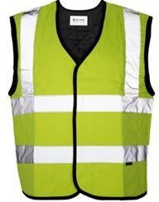
Figure 17-1 Hi-Visibility Vest
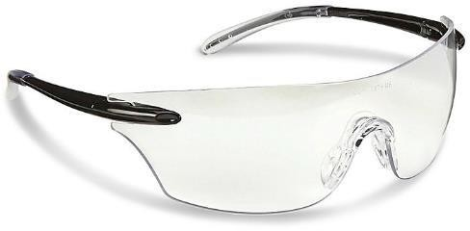
Figure 17-2 Approved Safety Glasses
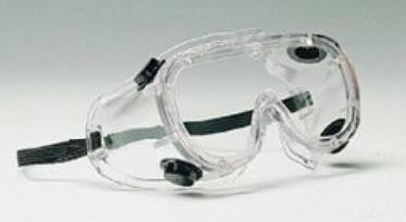
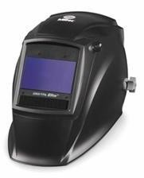
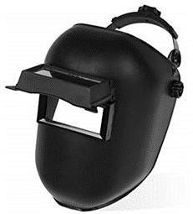
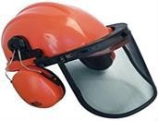
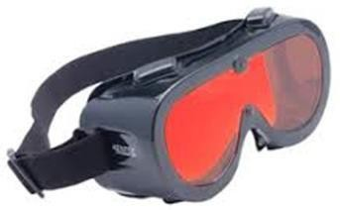
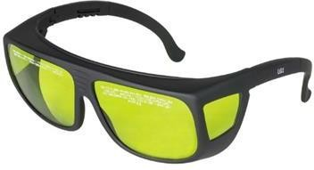
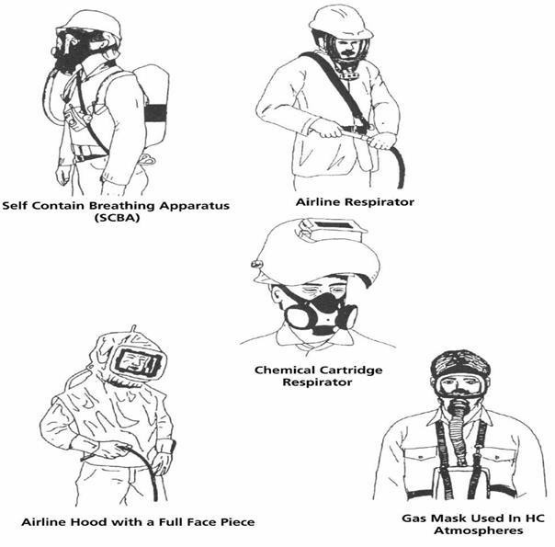
Figure 17-3 Types of Respiratory Protective Equipment (RPE)
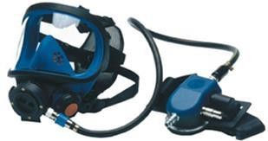
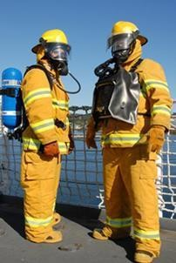
Figure 17-4 Self-Contained Breathing Apparatus (SCBA)
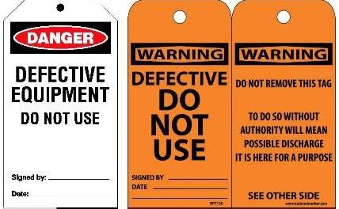
Figure 17-5 Sample Defective Equipment Tags

Revision History
Rev. | Date | Description of Change | Approved By
R00 | June 2026 | Initial issue. Restructured to the DAN integrated HSSE management-system template and re-branded in accordance with the DAN Brand Book. | Project Director
R01 | June 2026 | Re-coded to the updated DAN document-numbering convention (01-000001-000000-DAN-{discipline}-{type}-{seq}). | Project Director

